41.38: a)
b) This is the magnitude of the component of angular momentum perpendicular to the -axis. c) The maximum value is 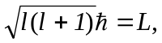 when 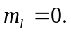 That is, if the electron is known to have no -component of angular momentum, the angular momentum must be perpendicular to the -axis. The minimum is 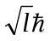when 